**(1) Reshape our image into single dimension :**

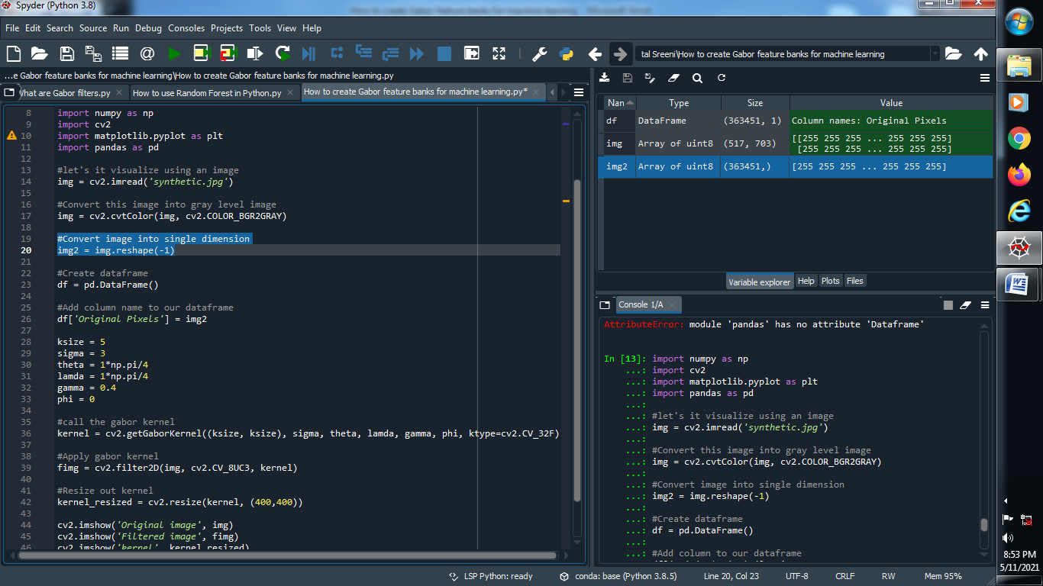

**Output :**



**(2) Create one data frame and give them one column name :**

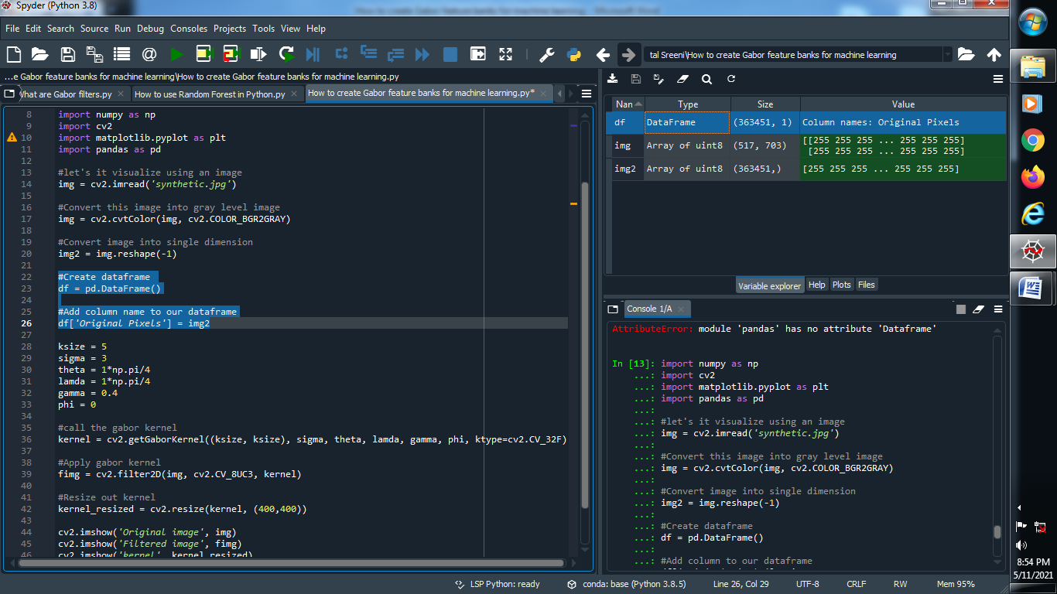

**Output :**



**(3) Create a range of values for theta, sigma, lamda, gamma :**

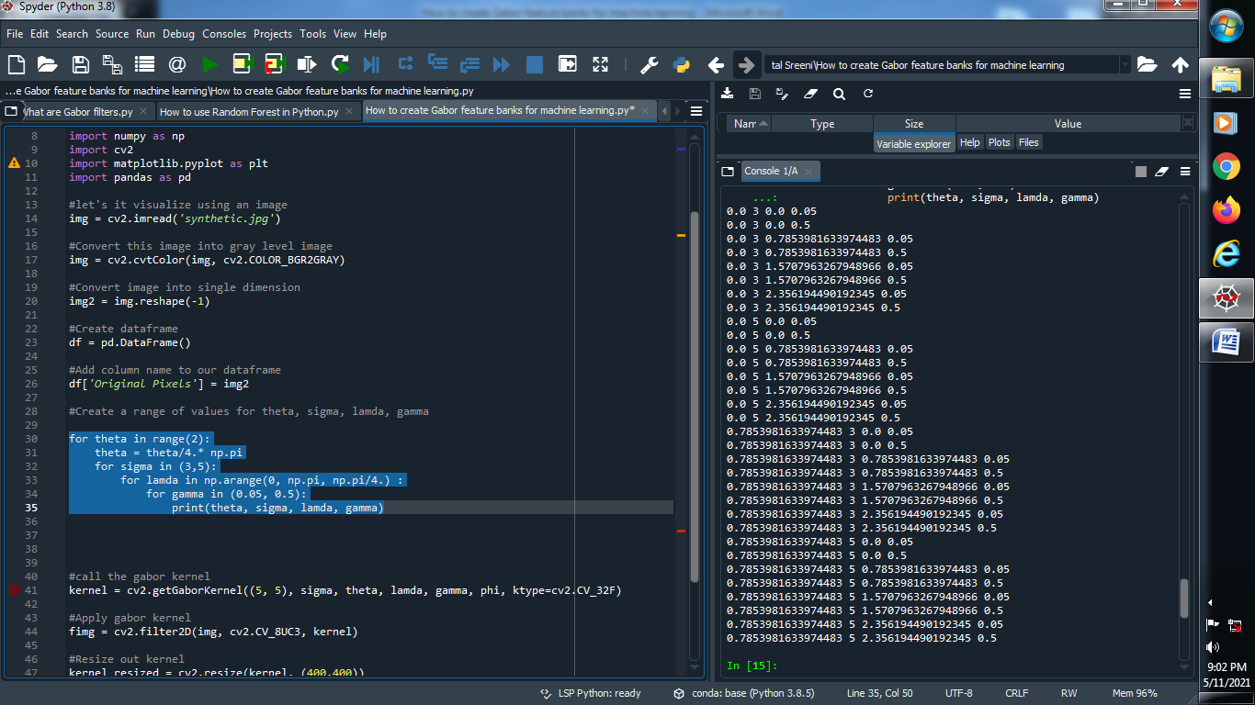

**Output :**



**(4) Create a gabor kernel and filter it and put all the values of all parameters :**

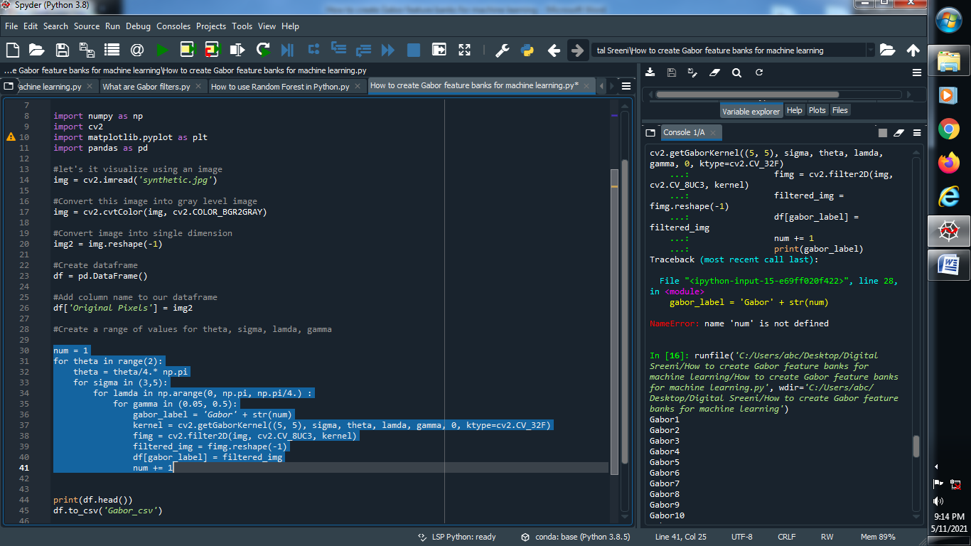

**Output :**

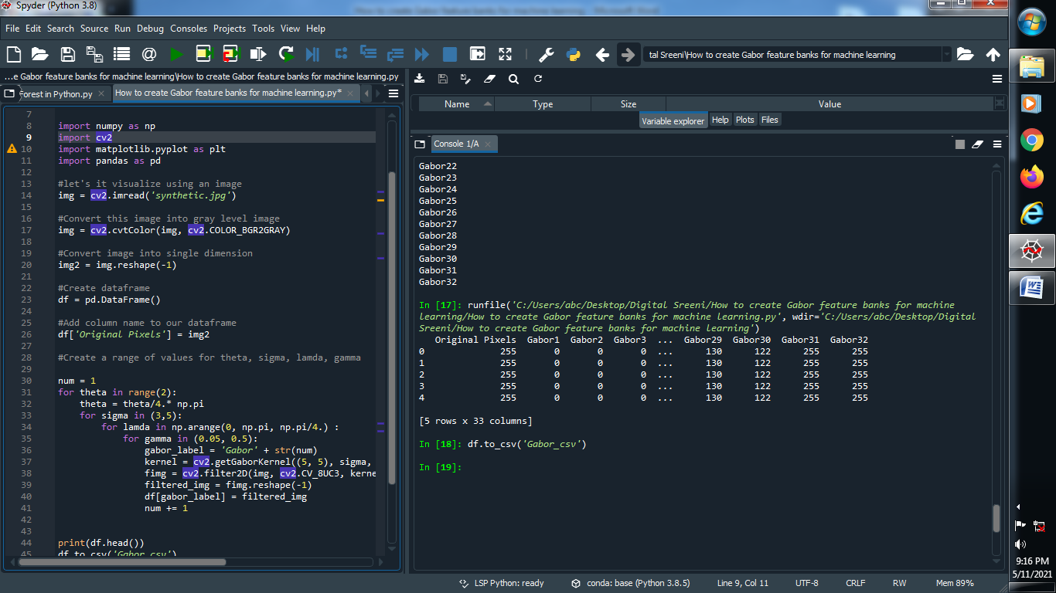

**(5) Create that csv file :**

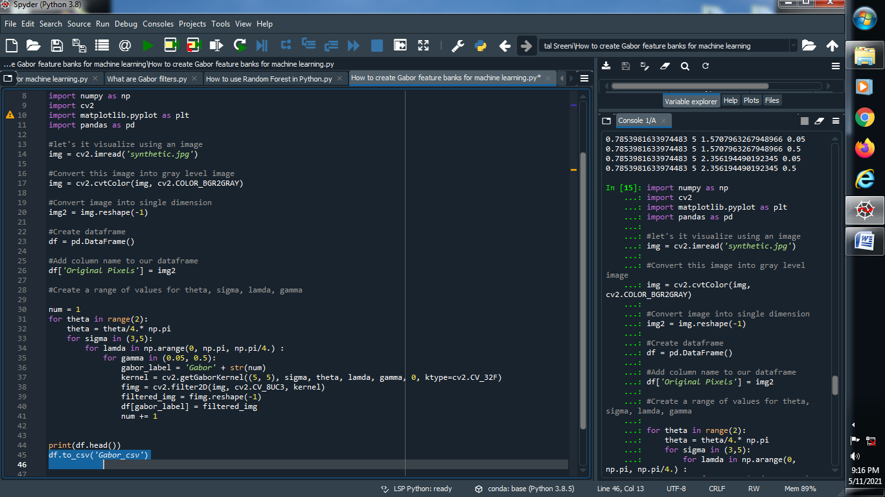

**Output :**

